How to run raster based version of the plugin

Before opening the plugin make sure that all the dataset that are needed to run it are loaded into your QGIS window. Make sure that all the datasets have the correct type. The datasets are the following:

Table 1. The datasets needed for the analysis. Their names are not important but the type is cruicial.

|  |  |
| --- | --- |
| Dataset | Type |
| Administrative boundaries | Polygon |
| Population | Raster or points |
| GHI | Raster |
| Wind speed | Raster |
| Travel hours | Raster |
| Nighttime lights | Raster |
| Elevation | Raster |
| Land cover | Raster |
| Existing transmission lines | Lines |
| Planned transmission lines | Lines |
| Substations | Points |
| Roads | Lines |
| Hydropower | Points |

**NOTE: The name of the datasets are arbitrary.**

**NOTE2: When you have made sure that you have all the datasets needed loaded into QGIS please create an empty folder (workspace) and name it after your country. This folder will serve as your workspace.**

**NOTE3: If you enter the wrong dataset in any of the boxes you might have to restart QGIS. To avoid this we will have to save the project as soon as all datasets are imported.**

1. **Open** the plugin from the **Database** menu. The name of the plugin when installed will be **Extract to Excel**
2. The following window will open up.

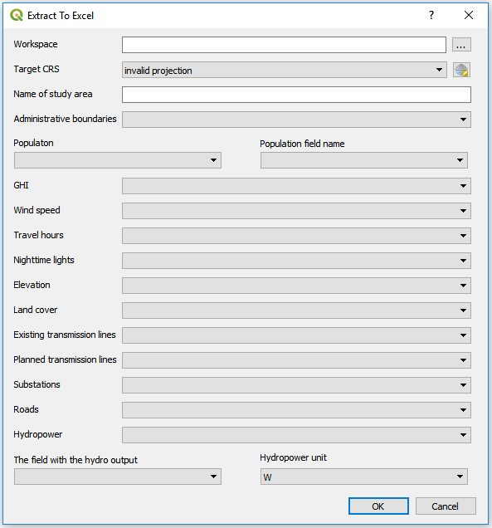

Figure 8. The plugin in use

Below information will follow regarding the use of each box

**Box 1**. This box lets you choose the workspace. Click on the three dots and navigate to the empty folder that you have created previously. When you have found it click ok and continue.

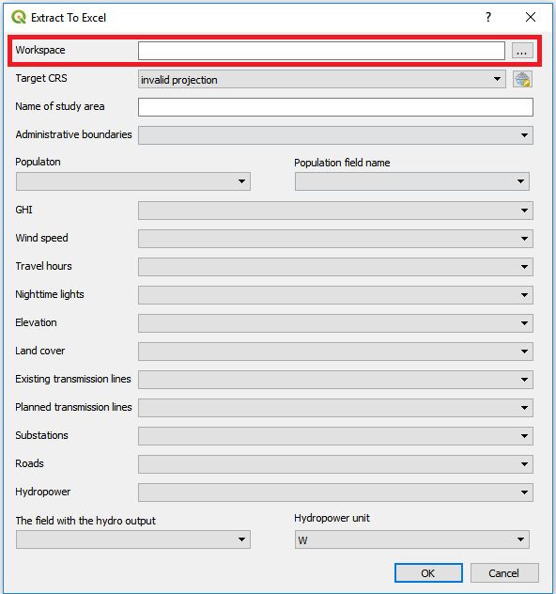

Figure 9. Box 1: enter the workspace by clicking on the button with three dots and navigate to the empty folder you are using as workspace

**Box 2**. This box lets you choose an appropriate coordinate system.

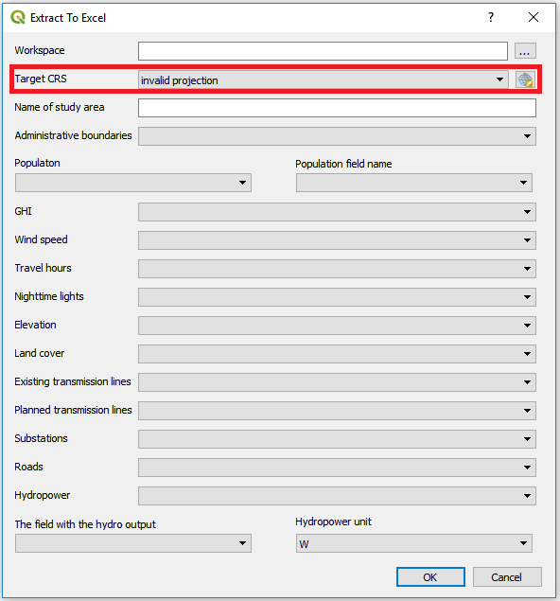

Figure 10. Box:2 choose the coordinate system that you want to reproject your data to.

To find the coordinate system that is appropriate for your country please visit <http://epsg.io/> and search for your country.

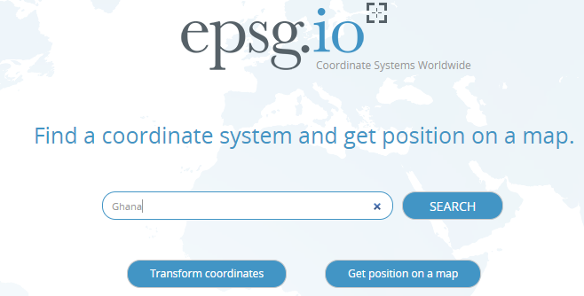

Figure 11. Go to epsg.io and search for the country you want to reproject

This will present you with a list of coordinate systems suitable for your study area.

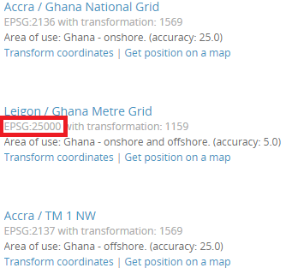

Figure 12. You will get a list of different coordunate systems that fit with your study area. Choose one and note its EPSG code.

Next, come back to QGIS. Click on the icon next to the field and check the EPSG code received from the webpage. Choose one where the unit is in meters and the red box covers the whole area you are working with.

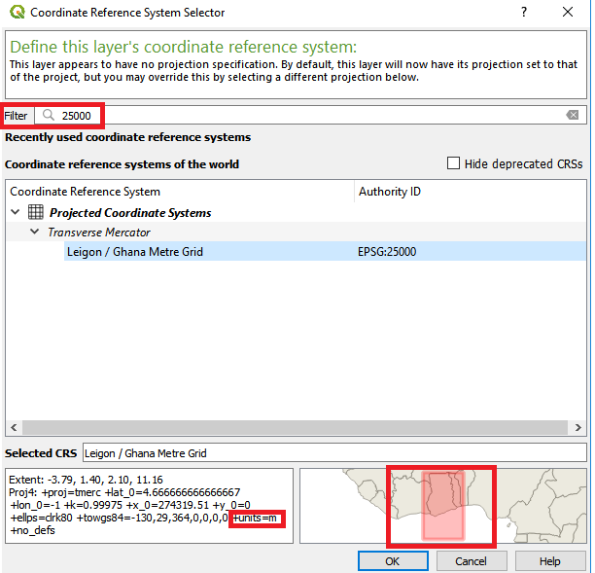

Figure 13. Enter the coordinate system you have chosen in the field. Make sure that the unit is meters (lower left box) and that the red area covers your study area (lower right box)

**Box 3**. Enter the name of your study area. This is the name that will appear on your csv output file.

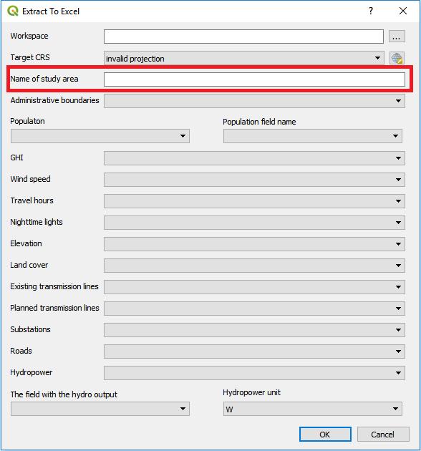

Figure 14. Enter the name of the study area this will be the name of the resulting csv file.

**Box 4**. Click on the box and select the administrative boundaries, make sure that it is a polygon layer.

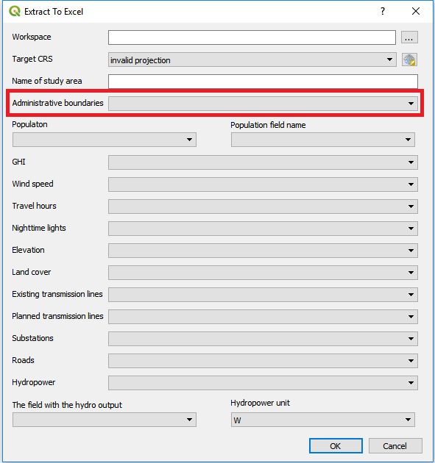

Figure 15. Enter the administrative boundaries.

**Box 5 and 6**. In box 5 select the population dataset. If the population dataset is a raster you can leave box 6 empty. If the population dataset is a point layer you will have to choose the column that represents the population in the attribute table in box 6.

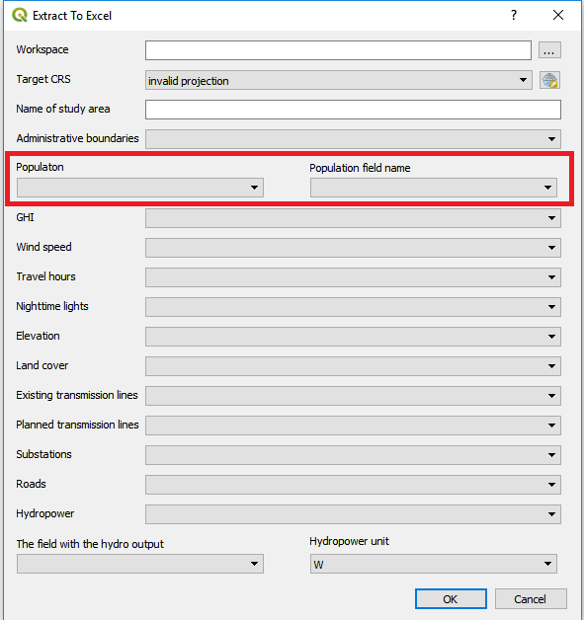

Figure 16. In the left box enter a population layer. If it is a point layer you will have to specify the population column in the right box. If it is a raster leave the right hand box empty.

**Box 7 – Box 16.** Select the correct dataset for the boxes

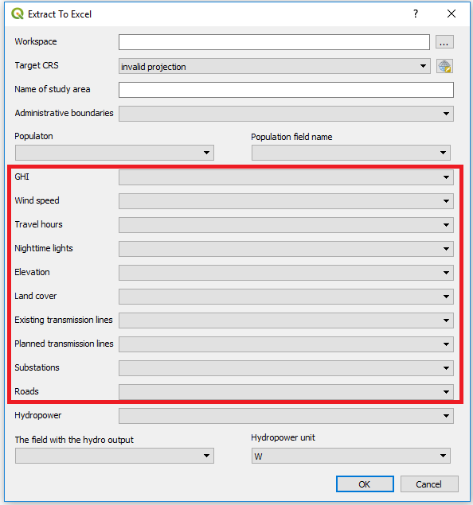

Figure 17. Fill in the correct datasets for each one of these boxes.

**Box 17.**  Click on the box and select the hydropower layer, make sure that it is a point vector.

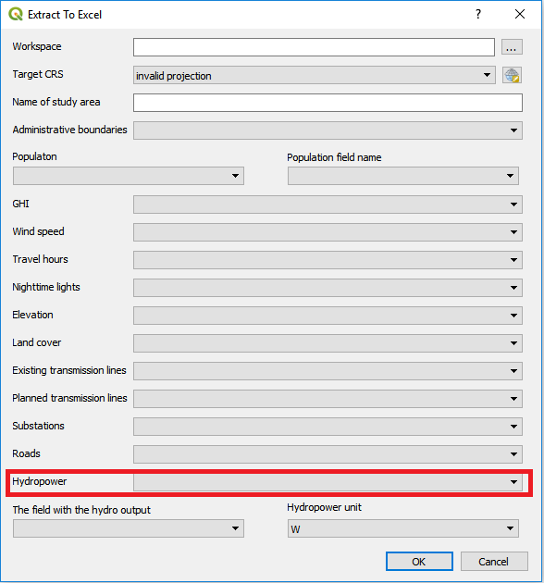

Figure 18. Hydropower points in this to be entered in this box

**Box 18.**  Select the box that includes the hydropower output (In this box you will select a column in the attribute table). The hydropower output is the potential electricity that can be outputted from each plant

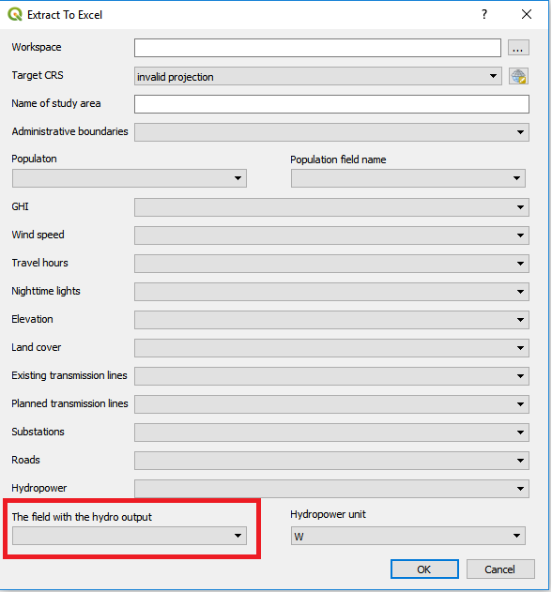

Figure 19. Field in the attribute table that includes the hydropower potential

**Box 19.**  Select the unit of that the hydropower output is given in. You get to choose between W, kW and MW.

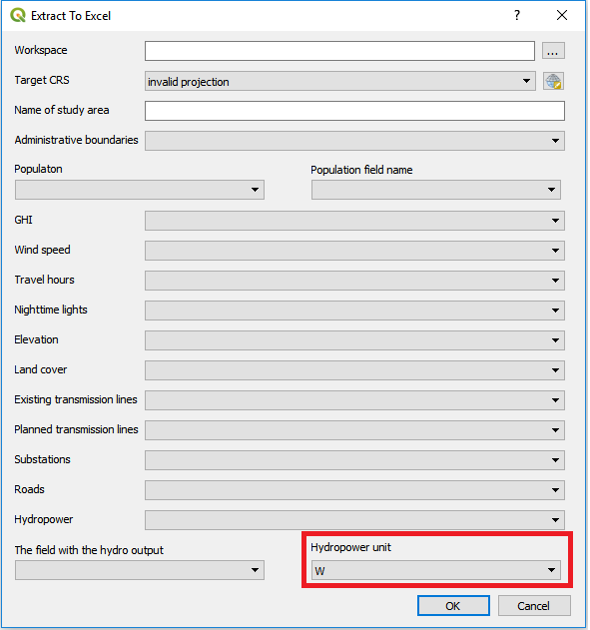

Figure 20. The unit of the values in Box 18

1. When all boxes have the correct data click “OK”. This will run the plugin. Depending on the size of the country this can take between 5 minutes and a number of hours.

When all the datasets are selected click “OK” to run the plugin

**Note:** While the plugin is running you will not be able to use QGIS. If you try to use QGIS you will get a loading icon. When the loading icon disappears the process is finished.